**Mobile Application Development (IFS324E)**

**ASSIGNMENT**

**3**

PLEASE NOTE

1. This cover page must appear at the beginning of your assignment submission and the template below must be used for your submission.
2. Type the assignment number in the space provide above.
3. All students who participated in this assignment must complete the table below, listing the names alphabetically by surname and taking note of the following:
   * 1. Each person is expected to contribute equally towards the total effort for the assignment.
     2. Each person’s percentage of total effort must be indicated. This will be used to calculate each person’s final mark for the assignment.
     3. If you are unable to sign this page physically, type your initials as your signature below. This will serve as your signature in all respects.
     4. By submitting this assignment, each person listed below declares that: this submission is his/her own work (not copied), that each person was an active participant in this assignment, and that his/her percentage of total effort stated is an accurate reflection of his/her total effort for this assignment.

## **PLEASE COMPLETE**

|  |  |  |  |  |  |  |  |  |
| --- | --- | --- | --- | --- | --- | --- | --- | --- |
| **Surname** | **First name** | | | **Student number** | **% of effort** | **Signature\*** |  | **Mark** |
| Jule | Tyson | | | 202126242 | 50% | T.Jule |  |  |
| Nene | Olona | | | 202016044 | 50% | O.Nene |  |  |
|  |  | | |  |  |  |  |  |
|  |  | | |  |  |  |  |  |
|  |  | | | **TOTAL:** | **100** |  |  |  |
|  |  | | |  |  |  |  |  |
|  |  | | |  | Mark (%): | |  |  |
|  |  | | | Less penalities (%): | | |  |  |
|  | |  | **Final mark (%):** | | | |  |  |

List names alphabetically by surname

* I declare that I have read the statements at the top of the page and acknowledge that the details I have provided are true. I also acknowledge that this assignment will not be assessed without the necessary declaration(s).

**Activity 1**

Copy and paste this activity template for each additional activity in this assignment.

1. **User Interface**

Paste a screenshot below of your app’s user interface. Crop the image to show just the app’s window. You can use the Windows 10 *Snipping Tool* to capture a screenshot.

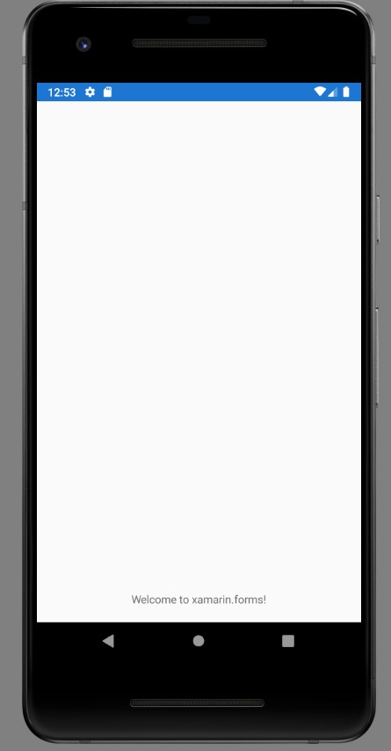

1. **Video Demonstration**

Insert (drag) a short video below to show the main functionality of your running app, but only if there is user interaction to demonstrate (i.e. where the user needs to interact with the app, such as click buttons or type in some input). If there is no user interaction to show, the user interface screenshot is sufficient. Do not discuss your code in the video – just show your app and how to use it (quickly, without unnecessary words or steps). Use a cell phone or a screen recording app. Use a common file format (e.g. MP4), but please ensure that the video is small and short (not high resolution!), otherwise your document will be too large to upload and download. Ensure that your video can play from this document.

1. **Solution Explorer**

Paste a screenshot of your solution’s *Solution Explorer* window to show the structure of your solution. Crop the image to show just the *Solution Explorer* window. Ensure that the text is readable.

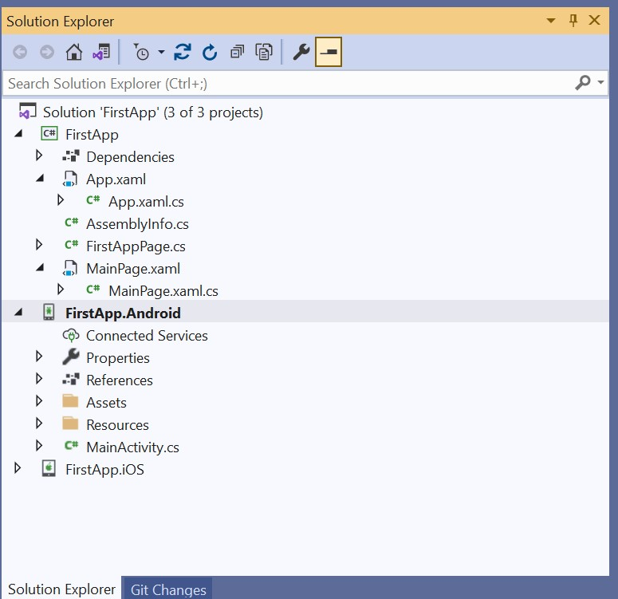

1. **Code Listings**

Paste the code/XAML from all the Visual Studio files that you created/changed for this activity, including **App.xaml.cs**. Do not paste screenshots of code. Select the code in Visual Studio, copy it to the clipboard and then paste it below. The name of the file must appear above each segment, as shown below.

## App.xaml.cs

## FirstAppPage.cs

## MainPage.xaml

